*Florida International University*

*School of Computing and Information Sciences*

Software Engineering Focus

Feature Document

User Story ID <NVOS-9 Data Structure Retrieved>

**Name:** Bryan Bastida

**Team Member(s):** Bryan Bastida

Andrew Castillo

**Project:** Envo Scholar

**Product Owner(s)**: Mark Finlayson

**Mentor(s)**: Masoud Sadjadi

**Instructor**: Masoud Sadjadi

**User Story Name:** Data Structure Retrieved

* Description: As a user, I want to retrieve the data structure from the database which contains the concepts, so that I can view it in the UI to then enhance my search query.

Acceptance Criteria

* User has typed a search query either in the homepage or the displayresults page
* Http GET request will be made to retrieve information from the database

**Use Case**

* **Name**: Data Structure Retrieved
* **Actor**: User and Web page
* **Preconditions**: User has accessed the Envo Scholar website

User has entered a search query

* **Postconditions**: Data structure has been retrieved from the database
* **Description** <Flow of events>:
  + User accesses the Envo Scholar website
  + Types a search query
  + Http GET request will be made to retrieve information from the database

**Use Case Diagram**

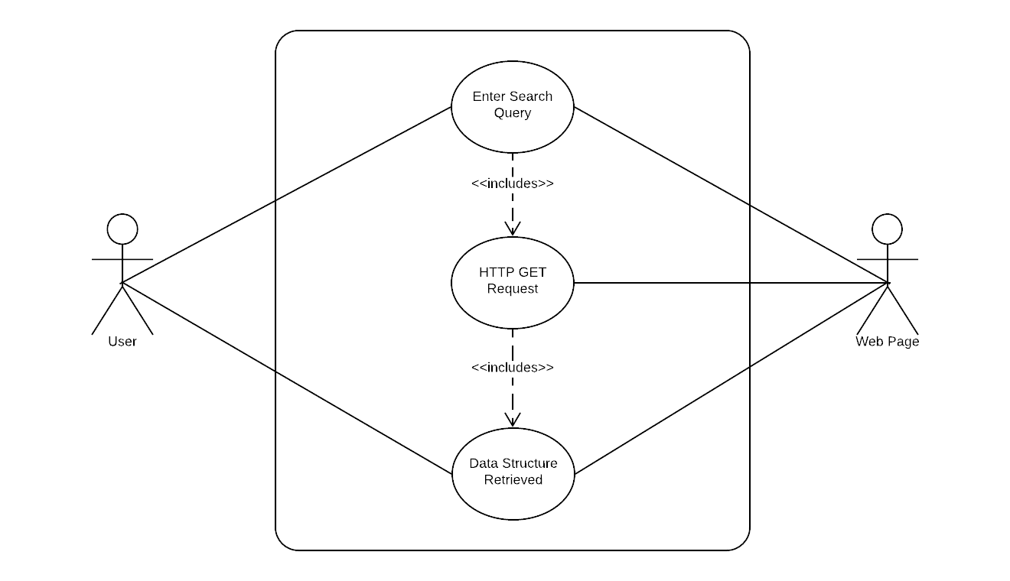

**Sequence Diagram**

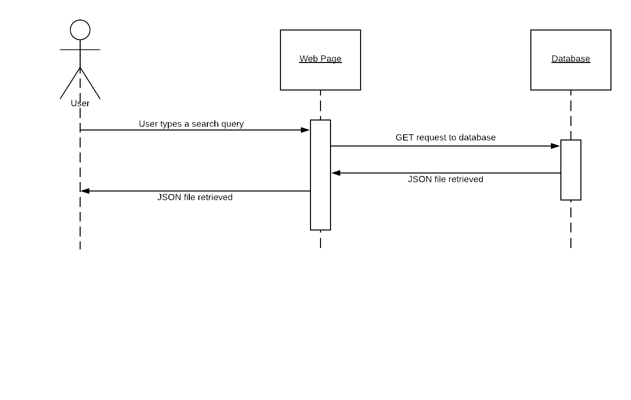

**Class Diagram**

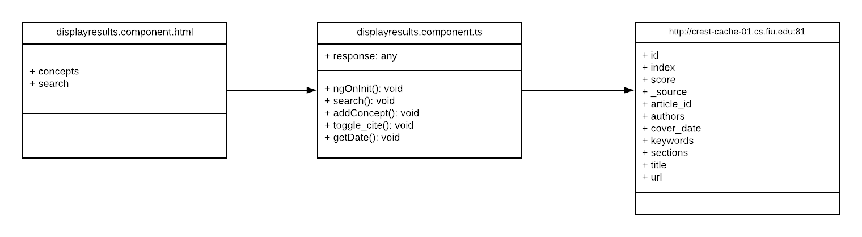

## ****Unit Test****

* Test case ID: NVOS-9-Data-Structure-Retrieved
* Description/Summary of Test: This test was to see if the JSON file was being retrieved from the HTTP GET request
* Pre-condition: A search query has been entered
* Expected Results: JSON file is retrieved
* Actual Result: JSON file is retrieved
* Status (Fail/Pass): Pass

**Visual User Guide**

